VILLAGE SACCO
Savings and Credit Co-operative Management System
A Java console application developed for
COS 3103 — APPLICATION DEVELOPMENT BY JAVA
Course Code | COS 3103
Course Name | Application Development by Java
Course Level | Year Three, Semester One
Credit Units | 4 CU — 60 Contact Hours
Student Name | Ntale Stephen
Registration No. | ………………………………………
Lecturer | ………………………………………
Date of Submission | ………………………………………

Source code: https://github.com/NtaleStephen/SACCO

Table of Contents
Right-click here and choose Update Field to build the contents.

1. Introduction

1.1 Background
A Savings and Credit Co-operative Organisation (SACCO) is a member-owned financial group in which people pool their savings and lend to one another at agreed rates. In Uganda and across much of the developing world, village-level SACCOs are the main source of credit for people whom commercial banks do not reach. Most still run on paper ledgers, which are slow to search, easy to lose, and difficult to audit.
This project implements a computerised management system for such a group. It was chosen because the domain exercises every topic on the COS 3103 outline through features that a real SACCO would genuinely need, rather than through artificial demonstrations written only to satisfy a syllabus.

1.2 Problem Statement
A manually operated village SACCO suffers four recurring problems:
- Slow member lookup — finding a member's record in a paper register is a linear search through hundreds of handwritten rows.
- Arithmetic errors — interest on savings and on loans is computed by hand each month, and mistakes are discovered late or not at all.
- Unfair loan queues — without a recorded order of applications, decisions can appear arbitrary, and members may be paid out of turn.
- Fragile records — a single damaged or lost ledger book destroys the group's entire transaction history.

1.3 Objectives
The general objective is to design and implement a Java application that automates the daily operations of a village SACCO. The specific objectives are:
- To register members with validated national identity and telephone details, guaranteeing that no person is registered twice.
- To operate savings accounts supporting deposits, withdrawals, transfers and a minimum-balance rule.
- To queue loan applications so that they are reviewed in a defensible order and disbursed strictly in the order approved.
- To compute monthly interest automatically, crediting savings accounts and charging loan accounts.
- To store all data on disk so that no information is lost when the program is closed.
- To demonstrate, in working code, each topic of the COS 3103 course outline.

1.4 Scope
The system is a single-user console application. It covers member management, savings and loan accounts, the loan approval workflow, interest, reporting and file-based persistence. It deliberately excludes a graphical user interface and a database server: the course outline covers neither, and the practical weight of the syllabus falls on object orientation, collections and I/O streams, which a console application demonstrates more directly.

2. System Overview

2.1 What the System Does
The system maintains a register of members, a set of accounts belonging to those members, a ledger of every transaction, and a queue of loan applications awaiting a decision. A clerk drives it through a numbered console menu. The application is organised around five areas of work, which correspond to the five processes shown in the data flow diagram of Figure 2.
Area | What it handles
Members | Registration with validation, roles, listings sorted by name or join date, grouping by role.
Accounts | Opening savings accounts, deposits, withdrawals, transfers, statements, closure.
Loans | Applications, risk scoring, the review queue, approval or rejection, disbursement, repayment.
Interest | A month-end run that credits every savings account and charges every loan account.
Files | Receipts, a binary transaction ledger, a saved object state, and bulk member import.

2.2 Users of the System
User | Role in the system | What they do
SACCO Clerk | Primary operator | Registers members, records deposits and withdrawals, prints receipts and statements.
Loan Committee | Approver | Reviews queued applications and approves or rejects them. Only members holding the Chairperson or Treasurer role may do this.
Member | Beneficiary | Saves, applies for loans and repays them. Does not operate the system directly.

2.3 Technology Used
Component | Choice | Reason
Language | Java (source level 7, built and tested on Java 17) | Required by the course. The code compiles cleanly at both levels.
IDE | Eclipse IDE for Java Developers | Specified in the course outline; the project imports directly.
Interface | Console (System.in / System.out) | Matches the syllabus, which contains no GUI topic.
Storage | Plain files — text, binary and serialised objects | Demonstrates Topic 11 in three contrasting forms.
Libraries | None beyond the JDK | Keeps the project self-contained and reviewable.

3. Requirements

3.1 Functional Requirements
Ref | Requirement | Where implemented
FR1 | Register a member with a 14-character national ID and a valid local phone number. | MemberService.register
FR2 | Reject a national ID that is already registered. | DuplicateMemberException
FR3 | Open a savings account with a minimum balance and an annual interest rate. | AccountService.openSavings
FR4 | Accept deposits and withdrawals, refusing a withdrawal that breaches the minimum balance. | SavingsAccount.withdraw
FR5 | Transfer funds between two accounts, reversing the first leg if the second fails. | AccountService.transfer
FR6 | Record every money movement as an immutable ledger entry. | Transaction
FR7 | Accept loan applications and score them for risk. | LoanApplication.riskScore
FR8 | Present applications to the committee lowest-risk first. | PriorityQueue` in `LoanService
FR9 | Disburse approved loans strictly in the order approved. | LinkedList` in `LoanService
FR10 | Enforce a loan ceiling determined by the member's role. | MemberRole.getLoanCeiling
FR11 | Credit interest to savings and charge interest to loans in one operation. | AccountService.runMonthEndInterest
FR12 | Produce a printed receipt and an account statement. | ReceiptPrinter
FR13 | Save and restore the complete system state. | StateStore`, `SaccoState
FR14 | Import members in bulk from a CSV file, skipping and reporting bad rows. | MemberImporter

3.2 Non-Functional Requirements
Ref | Requirement | How it is met
NFR1 | Data must survive the program closing. | Three independent file formats written on exit.
NFR2 | A corrupt data file must not crash the system. | Magic number, version check and truncation recovery in `LedgerStore`.
NFR3 | Invalid input must never terminate the program. | Every menu action is wrapped in targeted exception handling.
NFR4 | Monetary figures must be presented consistently. | All amounts formatted through `Money.format` using `%,.2f`.
NFR5 | The code must be readable and maintainable. | Six packages with a one-way dependency chain; no class exceeds ~300 lines.

4. System Design
This section presents the system first as data flows, then as code structure. The data flow diagrams follow the Gane–Sarson convention: rounded rectangles are external entities, circles are processes, and open-ended rectangles are data stores.

4.1 Context Diagram (DFD Level 0)
The context diagram fixes the boundary of the system. Everything inside the circle is the software being built; everything outside it is a source or destination of data that the system does not control. Note that the file store is modelled as an external entity, because persistence crosses the boundary of the running program.
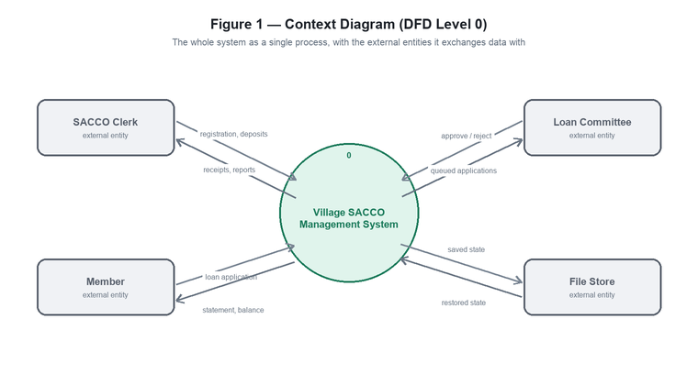
Figure 1 — Context diagram. The system as a single process with four external entities.

4.2 Level 1 Data Flow Diagram
Decomposing the single process gives five sub-processes and five data stores. Solid arrows show data being written, dashed arrows show data being read. The diagram makes the central design decision visible: process 4.0 reads account balances and writes interest transactions back into the ledger, so interest is recorded as ordinary ledger entries rather than as a special case.
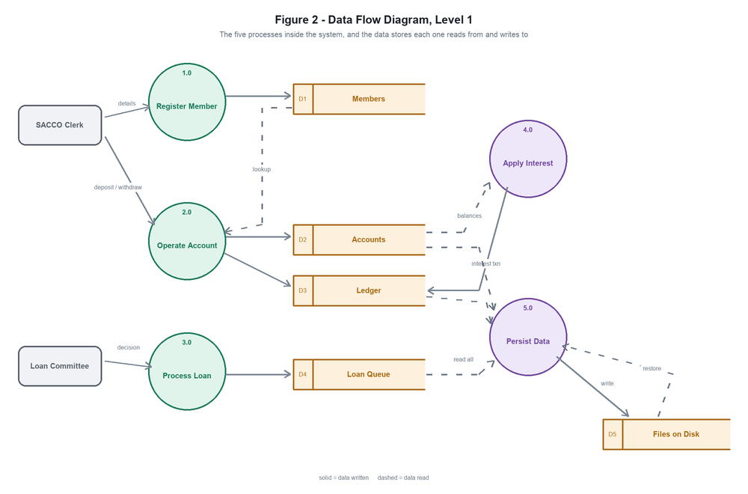
Figure 2 — Level 1 DFD. Five processes, five data stores.

4.3 Level 2 Data Flow Diagram — Process Loan
The loan process is decomposed further because it contains the only genuinely non-obvious design decision in the system: there are two queues, not one, and they are ordered by different rules. Applications awaiting review are held in a priority queue so that the committee sees the lowest-risk lending first. Once approved, an application moves to a strict first-in-first-out queue, because reordering who receives their money first would be impossible to defend to the membership.
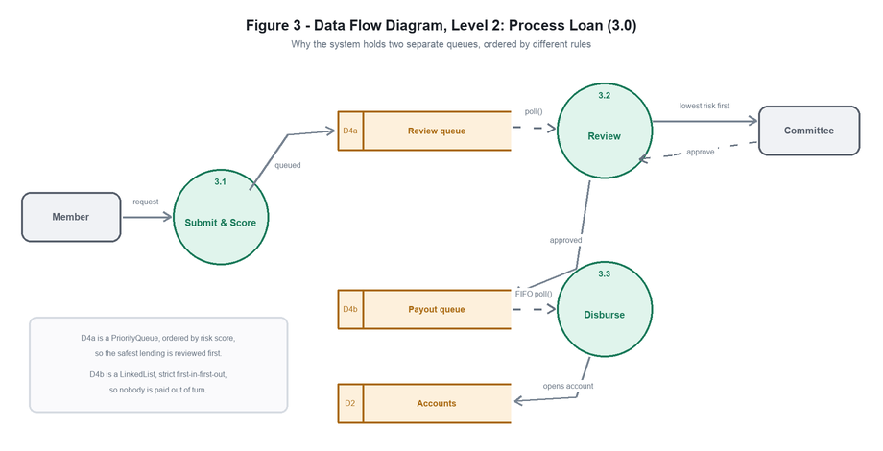
Figure 3 — Level 2 DFD for Process 3.0, showing the two differently-ordered queues.

4.4 Data Store Descriptions
Store | Contents | Java structure | Why that structure
D1 | Members | LinkedHashMap` + `HashSet | Map for instant lookup by ID; Set to guarantee one membership per national ID.
D2 | Accounts | LinkedHashMap | Constant-time lookup with a stable listing order between runs.
D3 | Ledger | HashMap<String, List<Transaction>> | One transaction history per account; order of accounts is irrelevant.
D4a | Review queue | PriorityQueue | Serves the lowest risk score first, regardless of arrival order.
D4b | Payout queue | LinkedList | Strict first-in-first-out; only the two ends are ever touched.
D5 | Files on disk | Text, binary and serialised | Three formats chosen for three different purposes (Section 4.7).

4.5 Package Architecture
The code is divided into six packages arranged in a one-way dependency chain. The user interface depends on the services, the services depend on the model, and the model depends on nothing. This means the domain classes can be reasoned about and tested without any reference to menus or files, and that all file access is confined to a single package.
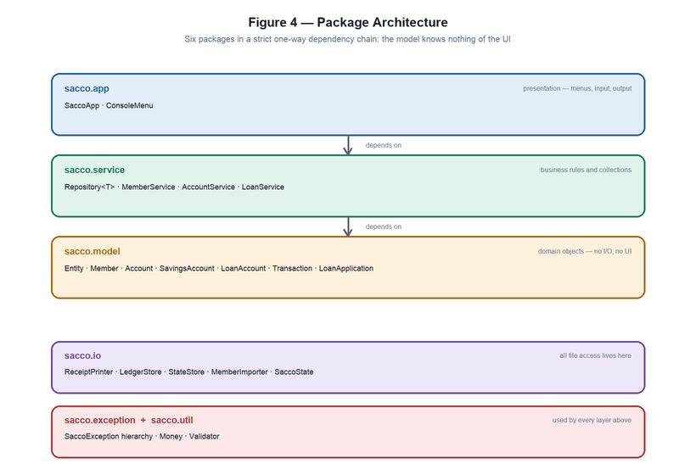
Figure 4 — Package architecture and the direction of dependencies.

4.6 Class Hierarchy
Every stored object extends the abstract class Entity, which supplies identity and the equals and hashCode contract that the hash-based collections depend on. Account is itself abstract: it holds what all accounts share and leaves the differences to its subclasses. The InterestBearing interface cuts across the hierarchy, which is precisely what single inheritance alone could not achieve.
The most instructive detail in the diagram is the method applyMonthlyInterest. In SavingsAccount it adds interest to the balance; in LoanAccount it charges interest, increasing the debt. The calling code in AccountService does not distinguish between the two — the object decides. That is polymorphism performing real work.
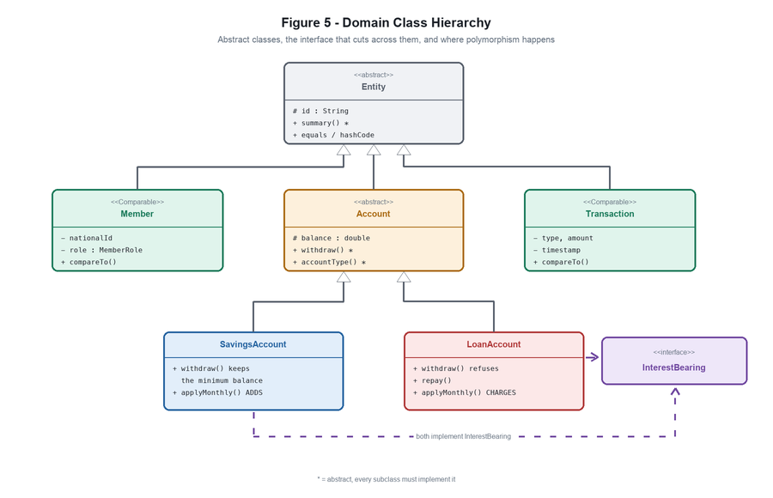
Figure 5 — Domain class hierarchy, abstract classes and the InterestBearing interface.

4.7 Loan Application Lifecycle
A loan application is a small state machine. The system enforces the transitions: an application that has already been decided cannot be decided again, and only an approved application can be disbursed. Both rules are implemented by throwing IllegalStateException rather than by silently ignoring the request.
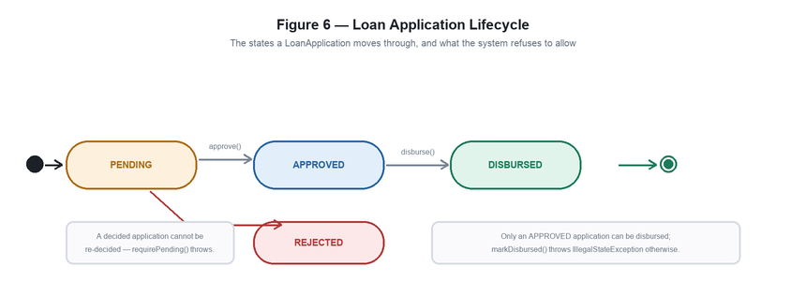
Figure 6 — States of a loan application and the guarded transitions between them.

4.8 Choice of File Formats
Three storage formats are used deliberately, because each is good at something the others are not. Comparing them is the core lesson of Topic 11.
File | Format | Written using | Suited to
receipts/*.txt | Character stream | PrintWriter | Human reading; any program on any platform can open it.
ledger.dat | Binary primitives | DataOutputStream | Compact and exact; a double is stored in 8 bytes with no parsing and no loss.
sacco.ser | Java serialisation | ObjectOutputStream | Saves an entire object graph, with shared references preserved, in a single call.

5. How the System Operates
This section follows the system in use. The screenshots are taken from a live session running inside Eclipse; where an operation is shown as a transcript rather than a screenshot, the text is the application's actual output, copied verbatim.

5.1 Importing and Building the Project
The project is supplied as a standard Eclipse project. It is imported through File → Import → General → Existing Projects into Workspace, selecting the project folder as the root directory and leaving ‘Copy projects into workspace’ unticked so that Eclipse works on the original files. Eclipse compiles the project on import.
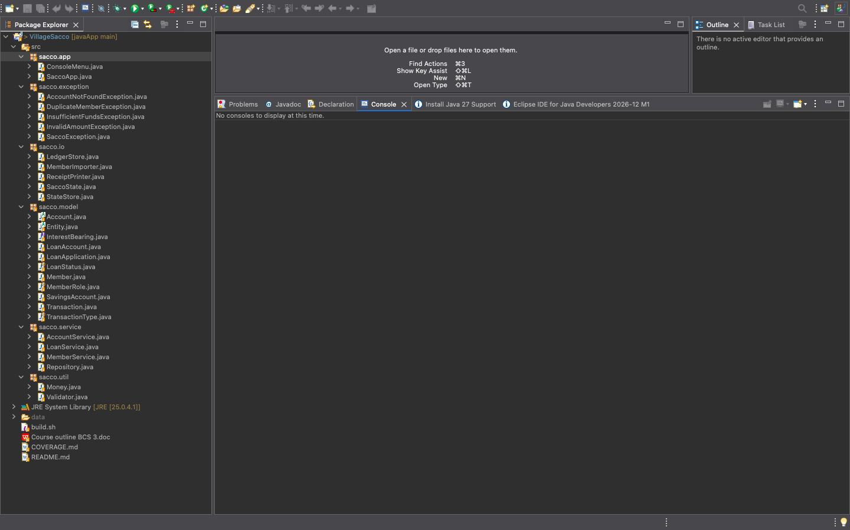
Screenshot 1: The VillageSacco project in Eclipse, with the Package Explorer expanded to show all six packages and their classes.

5.2 Starting the Application
On launch the application prints its banner, reports the currency in use, and either offers to reload previously saved data or seeds a sample SACCO. Sample data is requested with the --demo program argument, set under Run → Run Configurations → Arguments.
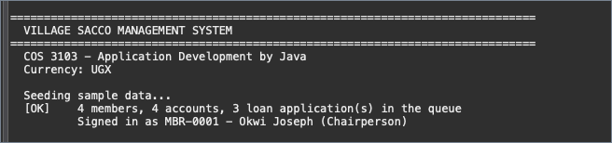
Screenshot 2: Startup with --demo: four members, four accounts and three loan applications are created, and the first officer is signed in.
The main menu follows, giving access to the five areas of the system. The signed-in officer is displayed beneath it, because only a member holding the Chairperson or Treasurer role is permitted to approve loans.
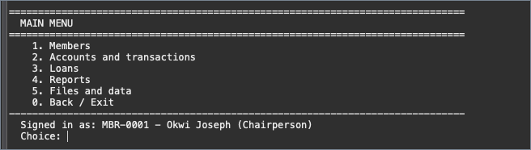
Screenshot 3: The five areas of the system, with the signed-in officer shown beneath.

5.3 Registering a Member
Registration prompts for a national identity number, a full name, a telephone number and a role. The identity number must be exactly fourteen alphanumeric characters and the telephone number must carry a recognised local prefix. Each role carries its own loan ceiling, which is displayed at the point of choice and later limits how much that member may borrow.
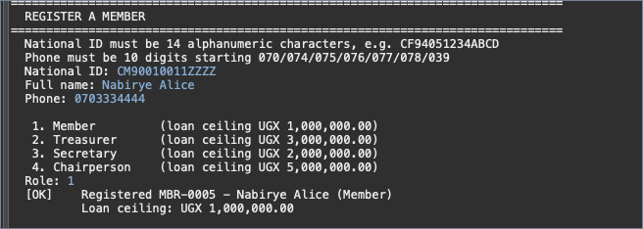
Screenshot 4: A successful registration. The system assigns the identifier MBR-0005 and reports the loan ceiling attached to the chosen role.

5.4 Input Validation
Invalid input is rejected with an explanation of what was expected, and the program returns to the menu rather than terminating. The screenshot below shows the national identity check refusing a value of the wrong length, reporting both the rule and the value that failed it.
Screenshot 5: The validation message produced when the national identity number does not meet the fourteen-character rule.
This is the behaviour described in requirement NFR3. The check is performed by Validator.isValidNationalId, and the failure is raised as an IllegalArgumentException that the menu layer catches and reports.

5.5 The Loan Workflow
The loans menu shows the state of both queues at all times: how many applications await review, and how many approved applications await payout.
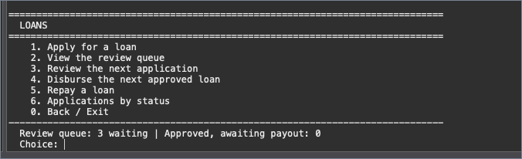
Screenshot 6: The loan options, with the review queue and payout queue counts displayed beneath.
Applications are scored for risk from the amount requested, the repayment term and the applicant’s length of membership. The queue then presents them lowest risk first. In the session below the three applications were submitted in the order APP-0001, APP-0002, APP-0003, but they are served in a different order entirely:
LOAN REVIEW QUEUE
==============================================================================
Served lowest-risk first (PriorityQueue order):
------------------------------------------------------------------------------
1. APP-0002 Nakato Grace 120,000.00 6m risk=3 PENDING Seed and fertiliser
2. APP-0003 Nakalema Sarah 450,000.00 12m risk=8 PENDING Shop stock
3. APP-0001 Mugisha Peter 900,000.00 24m risk=17 PENDING Boda boda purchase
------------------------------------------------------------------------------
The review queue served in risk order rather than submission order — the PriorityQueue of Figure 3 at work.
Once the committee approves an application it moves to the payout queue, which is strictly first-in-first-out. Disbursement then creates a loan account carrying the debt:
[OK] Disbursed UGX 120,000.00 to Nakato Grace
Loan account ACC-00005, 6 months, instalment UGX 21,800.00
Disbursement creates the loan account and reports the monthly instalment.

5.6 The Month-End Interest Run
A single operation applies one month of interest to every open account. The calling code makes the same call on each account; the object decides what that call means.
ACCOUNT INTEREST
------------------------------------------------------------------------------
ACC-00001 UGX 4,666.67
ACC-00003 UGX 1,225.00
ACC-00002 UGX 7,000.00
ACC-00005 UGX 1,800.00
ACC-00004 UGX 262.50
------------------------------------------------------------------------------
5 account(s), UGX 14,954.17 moved
One month of interest applied across all five accounts.
Listing the accounts afterwards shows the result. Every savings balance has risen because interest was credited; the loan balance has also risen, from 120,000.00 to 121,800.00, because interest was charged against it. The same method name produced opposite effects, decided entirely by the type of the object:
ACC-00001 Savings Okwi Joseph 804,666.67 min=20,000 rate=7.00%
ACC-00002 Savings Nakalema Sarah 1,207,000.00 min=20,000 rate=7.00%
ACC-00003 Savings Nakato Grace 211,225.00 min=20,000 rate=7.00%
ACC-00004 Savings Mugisha Peter 45,262.50 min=20,000 rate=7.00%
ACC-00005 Loan Nakato Grace 121,800.00 term=6m paid=0/6 rate=18.00%
Savings credited and the loan charged, from one polymorphic call site.

5.7 Refusing Invalid Operations
Attempting to withdraw from a loan account is refused outright, because LoanAccount overrides the inherited withdrawal behaviour and throws rather than allowing a meaningless operation:
[ERROR] You cannot withdraw from loan account ACC-00005; use repay()

Attempting to over-withdraw from a savings account reports exactly how far short the member is, because the exception object carries the figures and not merely a message. Closing an account that still holds money, and applying for a loan above the member’s role ceiling, are refused on the same principle.

5.8 Statements
A statement gathers an account’s full history into a bordered table with running balances and totals. It is built with a StringBuilder and written through a PrintWriter when saved to file.
+-----------------------------------------------------------------------------------+
| ACCOUNT STATEMENT |
+-----------------------------------------------------------------------------------+
| Account : ACC-00001 (Savings) |
| Member : Okwi Joseph [MBR-0001] |
| Balance : 804,666.67 |
+-----------------------------------------------------------------------------------+
| REF DATE TYP AMOUNT BALANCE NOTE |
| TXN-000001 2026-10-09 22:00:24 DEP 800,000.00 800,000.00 Opening balance |
| TXN-000007 2026-10-09 22:00:24 INT 4,666.67 804,666.67 Monthly inter...|
+-----------------------------------------------------------------------------------+
An account statement, showing the opening deposit and the interest credited by the month-end run.

5.9 Saving and Restoring Data
Saving writes both the complete object state and the binary ledger. On the next launch the application offers to reload. Because the identifier counters are restored along with the data, newly registered members continue the existing numbering instead of restarting at the first identifier and overwriting real records.
[OK] Object state written to data/sacco.ser
[OK] Binary ledger written to data/ledger.dat

... the application is closed and started again ...

Saved data was found. Load it? [y/n]: y
[OK] Loaded 8 member(s) and 5 account(s)
Binary ledger holds 11 transaction(s)
The save, and the restore on the following run. The two files are written and read independently of each other.

5.10 Bulk Import from CSV
Members can be imported from a comma-separated file. The supplied sample deliberately contains one malformed row. The importer skips it, reports the line number and the reason, and continues with the remainder of the file. A damaged line is treated differently from a damaged file: the first is skipped, the second aborts the import.
[OK] Imported 4, skipped 1
+ MBR-0005 - Nakato Grace (Member)
+ MBR-0006 - Okello Samuel (Treasurer)
+ MBR-0007 - Atim Betty (Secretary)
+ MBR-0008 - Mugisha Peter (Member)

[!] Rows that were skipped:
- Line 6: National ID must be 14 alphanumeric characters (got 'BAD-ID')
Bulk import: four valid rows accepted, the malformed row rejected with its line number and reason.

6. Implementation and Course Topic Coverage
The application was written so that every topic of the COS 3103 outline is demonstrated by code that has an actual purpose in the system. The table below maps each topic to where it can be found. A fuller map, down to individual method names, is supplied with the source as COVERAGE.md.
# | Course topic | Where it is demonstrated in the system
1–3 | Introduction, Getting Started, Eclipse | The project imports into Eclipse directly; build.sh documents the javac and java commands for building outside the IDE.
4 | Language Fundamentals | The menu loops are do-while; menu dispatch uses switch on int, on String and on enum; menu labels are held in String arrays and walked with the enhanced for loop; Validator uses char-level String inspection.
5 | Objects and Classes | Member shows instance data against the static counter that issues member IDs, overloaded constructors delegating with this(...), and every field private behind guarded accessors.
6 | Using Java Objects | printf formatting throughout; StringBuilder builds statements and StringBuffer builds the summary report, with the difference explained; equals and hashCode distinguish identity from equality; three enums carry their own data and behaviour.
7 | Inheritance | Entity to Account to SavingsAccount is a three-level chain. SavingsAccount.withdraw adds a rule then calls super; LoanAccount.deposit replaces the inherited meaning entirely.
8 | Advanced Inheritance and Generics | Entity and Account are abstract; InterestBearing is an interface implemented by both account types; Repository<T extends Entity> is a bounded generic reused three times; three classes implement Comparable and one Comparator provides an alternative ordering.
9 | Packages | Six packages; a static import of Money.format; and genuine package-private scope — Member.attachAccount is callable by Account because they share a package, and by nothing else.
10 | Exception Handling | A four-class checked hierarchy under SaccoException plus an unchecked InvalidAmountException, with the reason for each choice documented; multi-catch, finally and a catch of the common base type.
11 | Input/Output Streams | Character streams for receipts, byte streams for the binary ledger, object streams for saved state, and the InputStreamReader bridge used for both the CSV file and the keyboard.
12 | Core Collection Classes | Set, List, Queue and Map all used where each is genuinely the right tool, including two Queue implementations chosen for two different ordering requirements.

7. Testing and Results

7.1 Approach
The system was exercised by driving the console through complete scenarios and comparing the output against the expected result of each operation. Compilation was verified independently of the IDE using the command-line compiler with all warnings enabled.

7.2 Results
# | Test | Expected | Result
T1 | Compile all sources with all warnings enabled | No errors, no warnings | Pass
T2 | Review queue ordering | Applications served by ascending risk score, not submission order | Pass
T3 | Interest on a savings account | Balance increases by one twelfth of the annual rate | Pass
T4 | Interest on a loan account | Outstanding debt increases by the monthly charge | Pass
T5 | Withdrawal from a loan account | Refused with an explanatory message | Pass
T6 | Over-withdrawal from savings | Refused, reporting the exact shortfall | Pass
T7 | Loan above the member's role ceiling | Application refused | Pass
T8 | Closing an account with a non-zero balance | Refused | Pass
T9 | Save then restart and reload | All members, accounts and transactions restored; ID numbering continues | Pass
T10 | Truncated ledger file | Readable records recovered, warning issued, no crash | Pass
T11 | Foreign file supplied as the ledger | Rejected by the magic-number check | Pass
T12 | CSV import containing a malformed row | Valid rows imported, bad row skipped and reported | Pass

Compilation was confirmed from the command line with all warnings enabled:
$ javac -Xlint:all -d bin $(find src -name "*.java")
$ echo $?
0

The compiler reported no errors and no warnings. Eclipse’s own compiler likewise reports no problems for the project after import.

8. Limitations and Future Work

8.1 Known Limitations
These are deliberate, and are stated plainly rather than hidden:
- Monetary values use double. This is acceptable for a teaching project and keeps the focus on the course topics, but production financial software should use BigDecimal, because binary floating point cannot represent every decimal fraction exactly. Every arithmetic result is rounded to two decimal places to prevent the error from accumulating.
- Single user, no concurrency. Identifier counters are synchronised, but the system is not otherwise designed for simultaneous operators.
- No database. Persistence is to flat files, which is the subject of Topic 11; a multi-user deployment would require a database server.
- Interest is a flat monthly calculation rather than a full amortisation schedule, so the instalment figure is indicative.
- No authentication. Signing in as an officer selects a member; it does not verify a password.

8.2 Future Work
- Replace double with BigDecimal throughout and introduce a dedicated Money type.
- Add a proper amortisation schedule with per-instalment principal and interest splits.
- Introduce authentication and an audit trail recording which officer performed each action.
- Replace file storage with a relational database once concurrent access is required.
- Add automated unit tests, which would make future changes considerably safer.

9. Conclusion
The system meets the objectives set out in Section 1.3. It registers and validates members, operates savings and loan accounts, queues loan applications in a defensible order, computes interest automatically, and stores all data in three complementary file formats that survive restarts and tolerate corruption.
Beyond the functional result, the project demonstrates the full content of the COS 3103 outline in working code. The design decisions that carry the most teaching weight are the abstract Account class with its two very different subclasses, the single interest operation whose meaning is decided by the object rather than the caller, and the pair of loan queues ordered by different rules for reasons that come from the problem domain rather than from the syllabus.

References
Oracle (2014) The Java Tutorials. Available at: https://docs.oracle.com/javase/tutorial/
Oracle (2024) Java Platform, Standard Edition API Specification. Available at: https://docs.oracle.com/en/java/javase/17/docs/api/
Bloch, J. (2018) Effective Java. 3rd edn. Addison-Wesley.
Gane, C. and Sarson, T. (1979) Structured Systems Analysis: Tools and Techniques. Prentice-Hall.
The Eclipse Foundation (2026) Eclipse IDE for Java Developers Documentation. Available at: https://help.eclipse.org/

Appendix A — Building and Running the System

A.1 In Eclipse
1. File → Import → General → Existing Projects into Workspace.
2. Set the root directory to the project folder and ensure the project VillageSacco is ticked.
3. Leave 'Copy projects into workspace' unticked.
4. Right-click src/sacco/app/SaccoApp.java → Run As → Java Application.
5. For sample data, add --demo under Run → Run Configurations → Arguments.

A.2 From the Command Line
javac -d bin $(find src -name "*.java")
java -cp bin sacco.app.SaccoApp --demo
A helper script is supplied: ./build.sh compile, ./build.sh run, ./build.sh demo, ./build.sh clean.

A.3 Project Structure
src/sacco/app/ SaccoApp, ConsoleMenu
src/sacco/model/ Entity, Member, Account, SavingsAccount, LoanAccount,
Transaction, LoanApplication, InterestBearing, 3 enums
src/sacco/service/ Repository<T>, MemberService, AccountService, LoanService
src/sacco/io/ ReceiptPrinter, LedgerStore, StateStore, MemberImporter
src/sacco/exception/ SaccoException and four subclasses
src/sacco/util/ Money, Validator
data/ receipts, ledger.dat, sacco.ser (created at runtime)

A.4 Source Code
The complete source, together with COVERAGE.md mapping every course topic to the exact file and method that demonstrates it, is available at https://github.com/NtaleStephen/SACCO

